- When Complete | Creating an Individualized Behavior Support Plan  Complete Each Step
Select the target individual.
Select the target behavior that the team would like to help the individual change
Questions to consider: What behavior is having an impact on the individual’s ability to access learning, LRE, social opportunities, or safety?
What behavior is the team willing to focus on to learn a new process?

 | Identify underlying challenges that may be associated with the behavior. Informal assessment questions provided.  See Behavior Forms: Underlying Issues Student Profile | 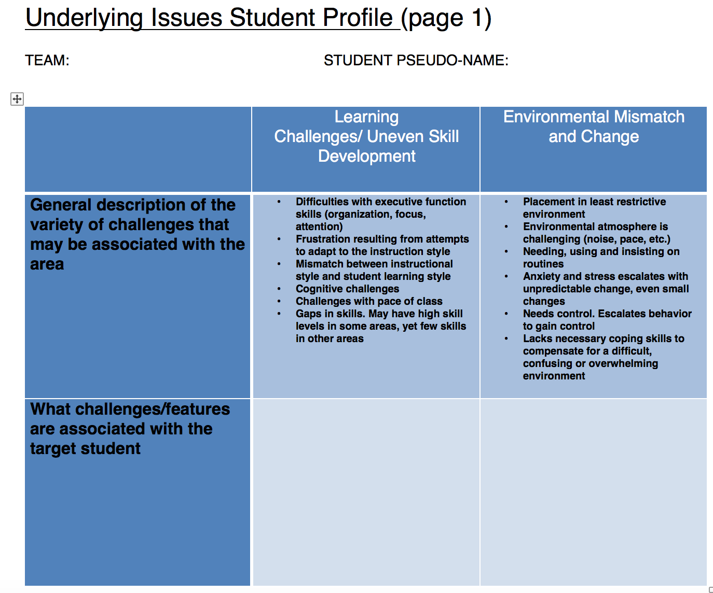
 | Define the behavior in measureable terms.  See Behavior Forms: Form 1 (Green Star Target Behavior Only) | 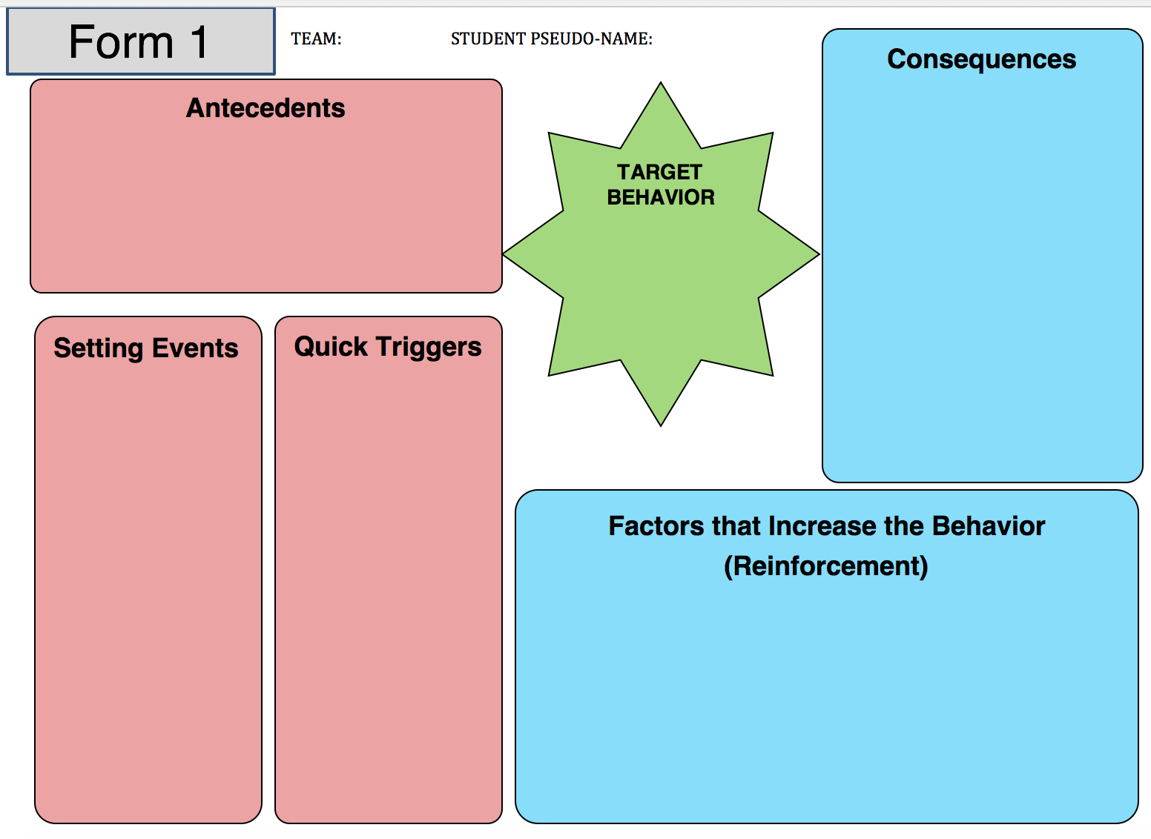
 | Consider data questions for identified behavior. What will you measure? Frequency? Duration? Intensity? How and When? Discuss what you have for baseline data and if you need more.  See Behavior Forms: Form 2 | 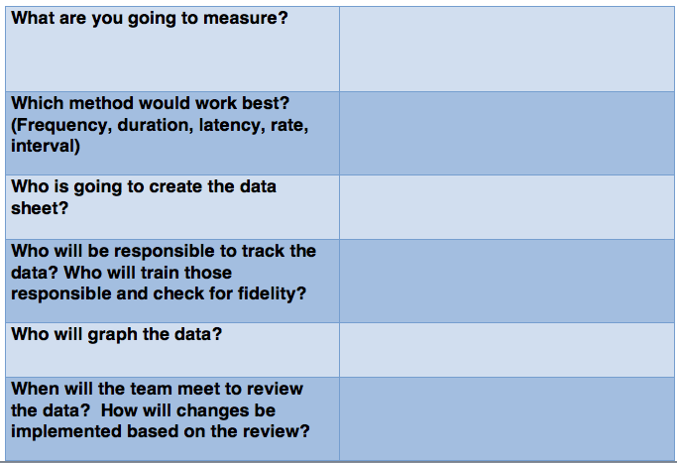
 | Identify antecedents, setting events, triggers, consequences, reinforcement. These are your initial ideas. You may refine as you go through the process. Guidance questions for potential antecedents and consequences are provided.  See Behavior Forms: Form 1 | 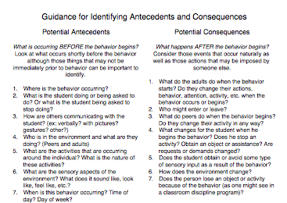
 | Complete the “Why Worksheet” using the information from the expanded FBA form. Develop your hypothesis about the behavioral function and explain why.  See Behavior Forms: Form 3 | 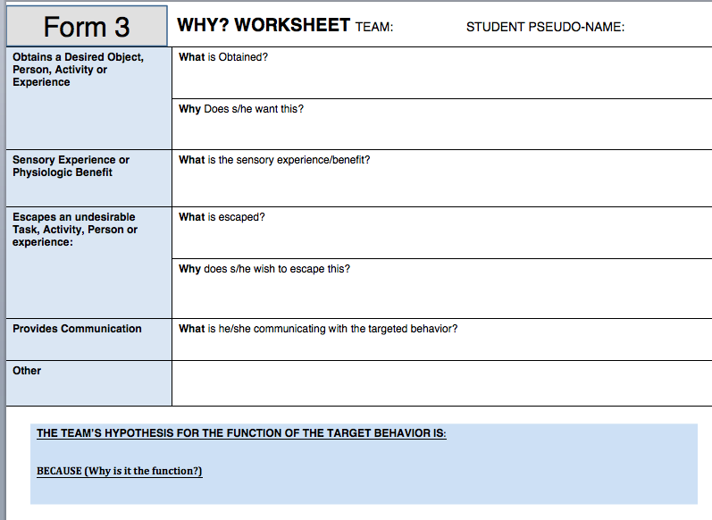
 | List strengths, interests, and preferences of the individual that can be used to help support a behavior change. This is the level to determine emerging skills and interests.  See Behavior Forms: Form 4 | 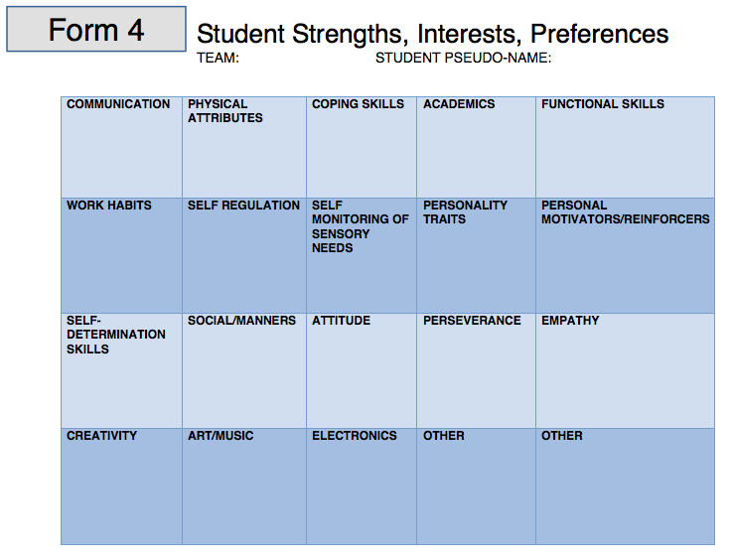
 | Identify Missing Skills needed to improve the target behavior. Review the individual’s current strengths and skills, looking for gaps in skill and knowledge that would be helpful and necessary. Guiding questions to help identify needed skills are provided.  See Behavior Forms: Form 5 | 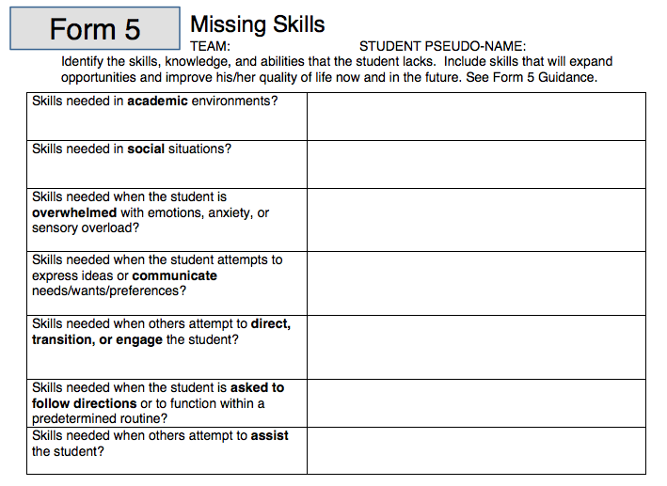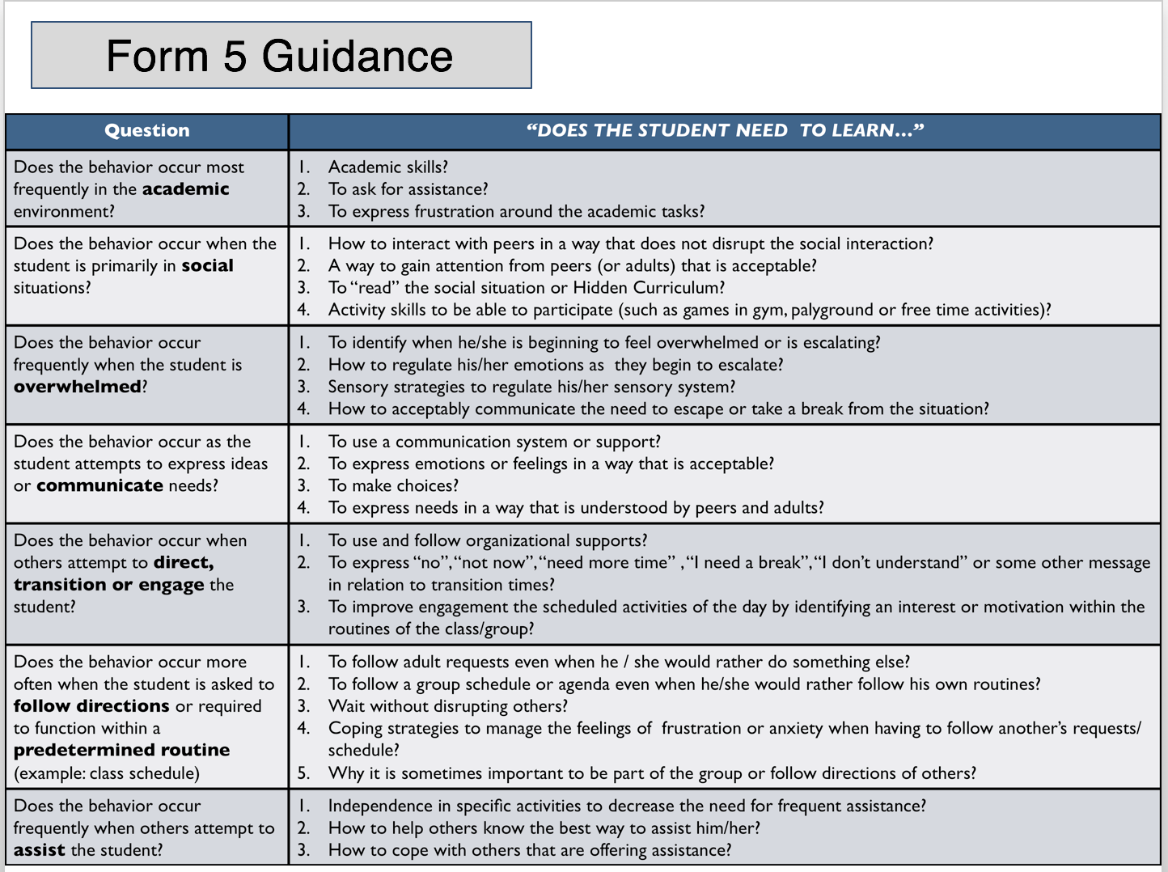
 | Identify Replacement Skill(s) and Related Skill(s) needed to change the target behavior and support learning. Show the flow from the Targeted behavior using the function to determine the Replacement behavior. Then consider the Resulting Consequences, Related Skills, and what the Long-term Outcome will be.  See Behavior Forms: Form 6 | 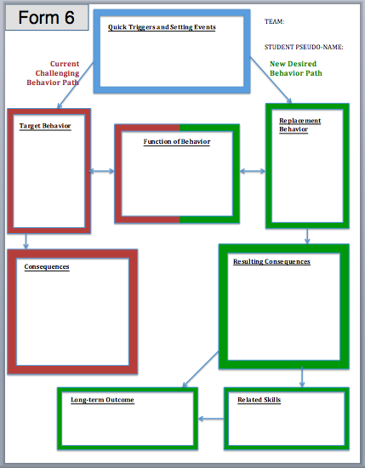
Identify possible interventions/strategies for identified replacement skills (forms 7a & 7b) and related skills (forms 7c & 7d). Align or connect the areas of challenge (Student Profile), strengths (form 4), and missing skills (form 5) with the selected strategies. Guiding questions to help choose interventions are provided. After choosing strategies/interventions, a strategy checklist (form 7e) is provided to be sure the team has covered all areas.
See Behavior Forms: Forms 7a, 7b, 7c, 7d, 7e

Consider reinforcement questions for identified behavior and intervention plans. You will individualize and improve success of the plan with the discovery of this information.
See Behavior Forms: Form 8

 | Choose the interventions/strategies/supports for the INITIAL implementation of the plan. Strategies to: teach the new skills to replace behaviors, reinforce new skills, change triggers and setting events, use strengths and individual motivators. Put on District Behavior Plan form, optional state form, or preferred Behavior Plan form.
 | Use Strategy Assessment and Revision Worksheet and Guiding Questions sheet to review strategies that will be part of the behavior plan | 