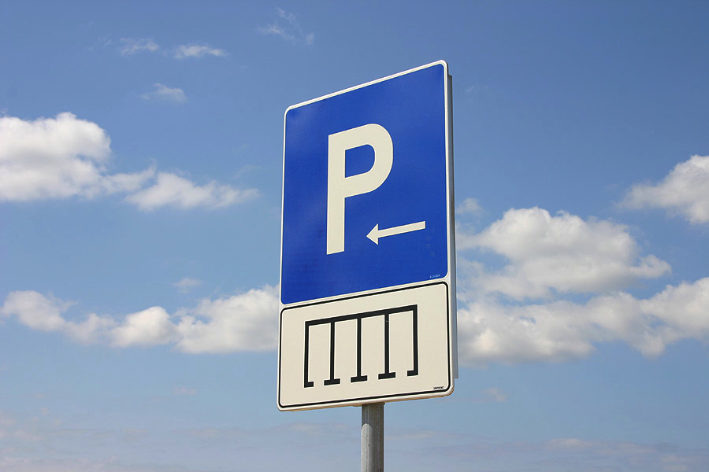

PARKING LOT
For important topics/interventions/strategies that come up in our discussions that need to be tabled until later. Print and write on this sheet.

