Ohio General Assembly’s Publicly Funded Child Care and Step Up to Quality Study Committee Testimony
March 16, 2022
Senator Cirino, Representative White and members of the Publicly Funded Child Care and Step Up to Quality Study Committee, thank you for your time and continued focus on this important topic.
My name is Teresa Kobelt and I am the Director of the Office of Policy at OCALI. By way of background, the General Assembly established OCALI in 2005 to serve as Ohio’s clearinghouse of information, professional development and technical assistance for autism and low incidence disabilities, including visual and hearing impairments, orthopedic disabilities, and traumatic brain injury.
At the core of OCALI’s work is the belief that all people can live their best lives for their whole lives. To that end, and through the support and leadership of our state partners, OCALI ensures families, educators, and service providers are equipped to effectively care for, support, educate, employ, and work alongside children and adults with disabilities. We are a trusted source of high-quality, accurate, reliable information and education.
This testimony is offered not only by OCALI, but on behalf of:
The Arc of Ohio
Autism Society of Ohio
Disability Rights Ohio
Down Syndrome Association of Central Ohio
Down Syndrome Association of Greater Cincinnati
Down Syndrome Association of Northeast Ohio
Down Syndrome Association of the Valley
Miami Valley Down Syndrome Association
Ohio Association of County Boards Serving People with Developmental Disabilities
Ohio Family and Children First Coordinators Association

When the federal Child Care and Development Block Grant (CCDBG) was reauthorized in 2014, four groups were prioritized: children who need care during nontraditional and variable hours, infants and toddlers, children in rural areas, and children with disabilities and special needs.

In Ohio, over 77,000 Medicaid-enrolled children under the age of 5 have a disability. That number increases to over 400,000 when we look at children under the age of 18 (Ohio Government Resource Center, Ohio Medicaid Assessment Survey). This number does not include children with other or no insurance. When we include those groups, the number is closer to 600,000.
As this committee fulfills its statutory obligation to consider “issues regarding access to publicly funded child care and quality-rated early learning and development”, we want to ensure these 600,000 children with disabilities and their families are indeed a priority population and not an afterthought of this work.

Why a Priority?
You have heard testimony on the critical nature of the earliest years of a child’s life, and how early investments literally change brain architecture and shape the future.
If you consider outcomes across the lifespan from kindergarten readiness to juvenile justice involvement, graduation rates to employment – people with disabilities consistently fare the worst. These are the same children who start off with the least access to high-quality, affordable, reliable, early care – with the least opportunity for change in trajectory.

Kindergarten Readiness
According to the Ohio Department of Education’s latest Annual Report on Kindergarten Readiness (2018), students with disabilities were the least likely to demonstrate readiness – lower than any other group.

Student Demographic | Per Cent Demonstrating Kindergarten Readiness
All students | 40.9
Students without disabilities | 44.7
Economically disadvantaged | 27.2
Black students | 25.9
Hispanic students | 24.1
English learners | 17.5
Students with disabilities | 14.4%
Juvenile Justice
Youth with disabilities are overrepresented in Ohio’s juvenile justice system. While students with disabilities account for approximately 15% of Ohio’s total student population, they account for almost 40% of youth in Ohio’s juvenile correction facilities and alternative placements (last reported by DYS July 2020).
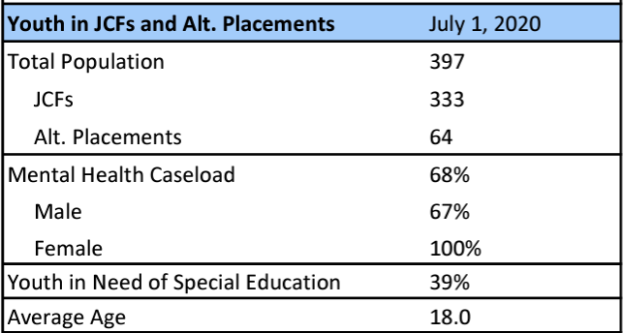
Graduation and Drop Out Rates
Ohio ranks 48th in the nation for students with disabilities graduating from high school, and has the 4th highest dropout rate for students with disabilities (Ohio Department of Education).
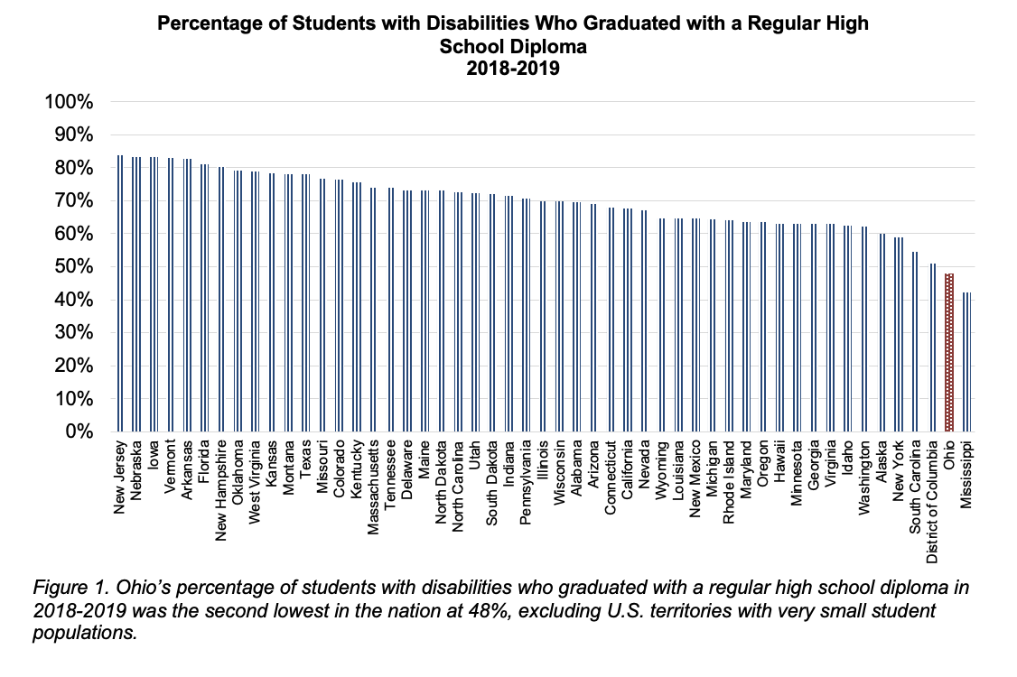

Employment
The gap only widens across the lifespan. According to the Bureau of Labor Statistics, before the COVID-19 pandemic (2019), only 40% of Ohioans with a disability had a job compared to 80% of Ohioans without a disability.
Almost any outcome we consider, whether related to healthcare, housing, educational attainment, you name it, it’s likely worse for people with disabilities.
Early Intervention and Special Education
Before I say more about this lack of access, I want to clarify a common misunderstanding: services under the Individuals with Disabilities Education Improvement Act (IDEA) are not the same as high-quality child care. Part C early intervention is not child care; preschool special education is not child care.

It is completely possible and very likely a family of a child with disabilities would be engaged in early intervention services – where they are present and involved and learning skills to build their competence and confidence in parenting their child. This service may be delivered for an hour a week or a month, likely in the family home or other natural environment. It is also completely possible and likely the parent(s) have jobs outside the home and need access to child care.

Similarly, a family with a child eligible for preschool special education may very well need care for that child before or after school or during the summer. Services delivered in accordance with IDEA do not meet families’ needs for high-quality child care.

Economic Impact
While many parents of young children leave their jobs, turn down offers, or make significant career changes due to problems with child care, “the odds of making a career sacrifice were three times higher for parents of children with disabilities…Considering the disproportionately high rates of poverty among people with disabilities, the additional resources that children with disabilities often need, and the onerous process of securing disability benefits for children, driving parents out of the workforce will likely exacerbate economic inequalities between families of disabled and nondisabled individuals.” (Center for American Progress emphasis added)
These families are significantly more likely to have low incomes, experience “cost-burden” (spend more than 30% of income on housing), have difficulty finding care, and experience disruptions in care than families without disability. (Urban Institute; National Disability Institute)

Americans with Disabilities Act
Even the youngest of our citizens are covered by the Americans with Disabilities Act (ADA). The ADA requires that child care providers not discriminate against persons, even infants and toddlers, with disabilities on the basis of disability. This applies to public and privately operated child care centers (with the exception of those operated by – not simply on the grounds of – a religious organization).

Under the law, children with disabilities must be provided an equal opportunity to participate in programs and services. Specifically:
- Centers cannot exclude children with disabilities from their programs unless their presence would pose a direct threat to the health or safety of others or require a fundamental alteration of the program.
- Centers have to make reasonable modifications to their policies and practices to integrate children, parents, and guardians with disabilities into their programs unless doing so would constitute a fundamental alteration.
- Centers must provide appropriate auxiliary aids and services needed for effective communication with children or adults with disabilities, when doing so would not constitute an undue burden.
- Centers must generally make their facilities accessible to persons with disabilities. Existing facilities are subject to the readily achievable standard for barrier removal, while newly constructed facilities and any altered portions of existing facilities must be fully accessible. (ADA.gov)
Some providers have told us that when considering serving a child with a disability, they weigh the risk. The two risks we most commonly hear are: losing their star rating should an adverse incident occur; incurring increased insurance costs.

Special Needs Child Care in Ohio
While the ADA is clear higher insurance rates, for example, are not valid reasons for excluding children with disabilities, we recognize there may be real costs involved.
Ohio does offer enhanced payments to providers serving children with “special needs”. If a child is determined to have special needs (by Job and Family Services), there are two mechanisms for enhanced payment.
First, if the child’s caretaker makes a request through the county department of job and family services and is determined eligible for special needs child care, providers can receive a 5% enhancement on top of the base rate. The additional 5% cannot exceed the provider’s customary charge to the public.
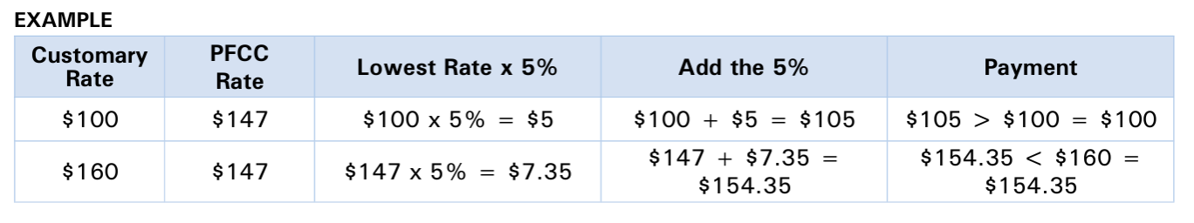
If a program needs to make adjustments to its service delivery model to serve a child with special needs (i.e., add an extra staff member in the room, decrease group size in the room, etc.), the program can submit documentation to ODJFS to request a 100% enhancement to its base rate for services provided to that child (this is in addition to the 5% mentioned above).
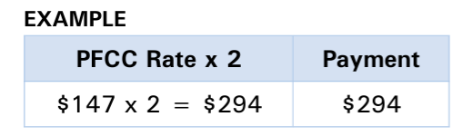
Ohio has financial incentives in place to serve children with special needs. Unfortunately, families report being unaware of these incentives, and providers report a combination of factors including: confusion over the process and lack of clarity around why some applications are approved and some are denied. Additionally, in many cases, the provider would incur cost “up front” (i.e., add a staff, lower a ratio, etc.) before knowing if they would in fact get the higher rate – only to have to discontinue service if the application is denied. At last ask, ODJFS reported less than 100 of these applications had been approved.
Considerations for this Committee
- Recognize the critical role of child care providers in identifying children with disabilities and their families. Well-trained child care providers are key to screening and monitoring. They are versed in developmental milestones, understand how and where to make referrals, and know how to have difficult conversations with families. As this committee considers high-quality child care, how is developmental screening and monitoring and provider training being factored in?
- Prioritize children with disabilities and special needs in the work of this group. These children are a priority population for Ohio’s federal child care block grant funds and must be provided an equal opportunity to participate in programs and services. To what extent does Ohio’s data suggest these children have access? What portion of federal funds is going to support this priority group?
- Invite the voice of families and child care providers to specifically discuss children with special needs. You will hear the barriers, the fears, the creative solutions. How do families and providers experience the application process? What are families of children with disabilities looking for – what kind of training or qualifications, environmental conditions, or support needs do their children have? How confident do providers feel serving these children? What are the most common accommodations or modifications providers are asked to make? What’s working? What’s not?
Early experiences that consist of healthy relationships and effective interventions influence lifelong outcomes. It is time to ensure that early childhood science, policy, and practice are integrated so that all Ohio’s children can live their best lives for their entire lives.
Submitted by:
Teresa Kobelt, Director, Office of Policy
OCALI
Teresa_kobelt@ocali.org

Ohio Revised Code (ORC) Section 5104.01 defines special needs child care as “care provided to a child who either has one or more chronic health conditions or does not meet age-appropriate expectations in one or more areas of development, including social, emotional, cognitive, communicative, perceptual, motor, physical, and behavioral development. Special needs child care may include, on a regular basis, services, adaptations, modifications, and/or adjustments to assist in a child’s functioning or development. Children in special needs child care may continue to receive publicly funded child care (PFCC) until they are 18.

