EXPECT SUCCESS SERIES:

Behavior Process and Guidance Forms
Learning Challenges/Uneven  Skill Development | Environmental Mismatch & Change | Sensory  Biological Challenges | Difficult to  Motivate | Social  Challenges | Emotional Challenges | Communication Challenges
What are the cognitive challenges?  Is the student missing key skills that are needed to learn the material being presented?  How does the teacher’s classroom approach/style match how this student learns?  Does the student have the supports needed to be organized with work materials and to approach assignments/homework?  What supports does the student need to be at optimal learning level?  What accommodations are needed for successful learning? | Do changes in routines impact this student?  Is the student overwhelmed by the physical environment of the classroom?  Is the student affected by the noise level, teaching presentation, response modes, pace of class, etc.?  What coping skills does this student have to deal with challenges in the classroom?  How has LRE been considered for this student? | Is the  student/team aware of sensory needs?  Are sensory supports built into the day?  What coping skills does the student utilize when sensory challenges arise?  What physical needs impact the student?  Are medications a factor?  Is the student impacted by co-occurring conditions and/or diagnoses? | Does the student understand why the content being taught is important? Is there a connection to his/her knowledge?  Does the student value learning? If not, what does the s/he value?  What reinforcement has meaning for this student?  When does the student need additional reinforcement?  Does the student have special interests that could be used as reinforcement within work or as positive reinforcement following work? | Does the student have the level of social competence needed to understand the various school settings?  What social skills is the student missing in order to actively participate?  What problem-solving skills does the student need to meet the social situations in his/her life?  What social rules does the student understand, but not apply yet? | Can the student identify his/her own emotions?  Can the student identify/react appropriately to the emotions of others?  Does the student apply problem solving skills to situations that raise anxiety, anger, happiness, and other emotional levels?  What coping skills does the student make use of in emotionally charged situations? | Does the student have a functional communication system available at all times?  Are differences in expressive/receptive language recognized?  Are directions given in a way that is clear for all students?  Does the student understand the adult/student communication expectations in each school situation/setting?  What coping skills does the student use in communication situations?
Guiding Questions for Underlying Issues
Underlying Issues Student Profile (page 1)
TEAM: STUDENT PSEUDO-NAME:
 | Learning  Challenges/ Uneven Skill Development | Environmental Mismatch  and Change
General description of the variety of challenges that may be associated with the area | - Difficulties with executive function skills (organization, focus, attention)  - Frustration resulting from attempts to adapt to the instruction style  - Mismatch between instructional style and student learning style  - Cognitive challenges  - Challenges with pace of class  - Gaps in skills. May have high skill levels in some areas, yet few skills in other areas | - Placement in least restrictive environment  - Environmental atmosphere is challenging (noise, pace, etc.)  - Needing, using and insisting on routines  - Anxiety and stress escalates with unpredictable change, even small changes  - Needs control. Escalates behavior to gain control  - Lacks necessary coping skills to compensate for a difficult, confusing or overwhelming environment
What challenges/features are associated with the target student

Underlying Issues Student Profile (page 2)

TEAM: STUDENT PSEUDO-NAME:

 | Sensory/Biological Challenges | Difficult to  Motivate
General description of the variety of challenges that may be associated with the area | - Emotions and anxiety that result from difficulty tolerating certain aspects of sensory input (light, sounds, touch)  - Need sensory input (such as movement) to stay alert and focused  - Multiple medical conditions impact the ability to learn  - Side effects from medications  - Impact of co-occurring conditions/diagnoses | - Does not see relevance of what s/he is learning  - Does not value learning and new knowledge  - Is not motivated by typical reinforcements  - Hyper–focused on areas of interests to the exclusion of other areas  - Lacks awareness of the importance of having a broad range of skills or knowledge
What challenges/features are associated with the target student

Underlying Issues Student Profile (page 3)
General description of the variety of challenges that may be associated with the area | - Problems understanding and adjusting to the social rules in a variety of situations  - Knowing the social rules (acquisition) but not being able to apply them (performance)  - Difficulty problem-solving what to do in social situations  - Difficulty accurately interpreting social messages from others  - Lacks Coping Skills to tolerate the social situations | - Difficulties expressing needs, wants, feelings, emotions, ideas, etc.  - Difficulty accurately interpreting and understanding emotional messages from others  - Wanting exclusive attention of others, or avoids attention from others  - Difficulty problem-solving what to do about emotional challenges  - Lacks Coping Skills to tolerate the situations of challenge and confusion | - Difficulty sharing wants and needs  - Knowing the appropriate pragmatics (rules for social language) to use  - Being able to understand and follow directions  - Difficulty using language appropriate to a variety of situations  - Limited or no functional way to communicate  - Lacks Coping Skills to tolerate the challenge and confusion of communication situations
What challenges/features are associated with the target student

 | Social Challenges | Emotional  Challenges | Communication Challenges
TEAM: STUDENT PSEUDO-NAME:

TEAM: STUDENT PSEUDO-NAME:
Factors that Increase the Behavior (Reinforcement)

Quick Triggers

Setting Events

Consequences

TARGET BEHAVIOR

Antecedents

Form 1

What happens AFTER the behavior begins?

Consider those events that occur naturally as well as those actions that may be imposed by someone else.
- What do the adults do when the behavior starts? Do they change their actions, behavior, attention, activity, etc. when the behavior occurs or begins?
- Who might enter or leave?
- What do peers do when the behavior begins? Do they change their actions in any way?
- What changes for the student when s/he begins the behavior? Does s/he stop an activity? Obtain an object or assistance? Are requests or demands changed?
- Does the student obtain or avoid some type of sensory input as a result of the behavior?
- How does the environment change?
- Does the person lose an object or activity because of the behavior (as one might see in a classroom discipline program)?
What is occurring BEFORE the behavior begins?

Look at triggers that occur shortly before the behavior and at setting events that can make the behavior more likely to happen.
- Where is the behavior occurring?
- What is the student doing or being asked to do or asked to stop doing?
- How are others communicating with the student?
- What is impacting the student? (sleep, medications, illness, etc.)
- Who is in the environment and what are they doing? (Peers and adults)
- What are the activities that are occurring around the individual? What is the nature of these activities?
- What are the sensory aspects of the environment? What does it sound like, look like, feel like, etc.?
- When is this behavior occurring? Time of day? Day of week?
Potential Antecedents
Potential Consequences
Form 1 Guidance
Form 2

Your Student and Data for the Targeted Behavior

TEAM: STUDENT PSEUDO-NAME:
What are you going to measure?
Which method would work best? (Frequency, duration, latency, rate, interval, intensity)
Who is going to create the data sheet?
Who will be responsible to track the data? Who will train those responsible and check for fidelity?
Who will graph the data?
When will the team meet to review the data? How will changes be implemented based on the review?

WHY? WORKSHEET TEAM: STUDENT PSEUDO-NAME:
THE TEAM’S HYPOTHESIS FOR THE FUNCTION OF THE TARGET BEHAVIOR IS:

BECAUSE (Why is it the function?)
Form 3
Obtains a Desired Object, Person, Activity or Experience | What is Obtained?
 | Why Does s/he want this?
Sensory Experience or Physiologic Benefit | What is the sensory experience/benefit?
Escapes an undesirable Task, Activity, Person or experience: | What is escaped?
 | Why does s/he wish to escape this?
Provides Communication | What is he/she communicating with the targeted behavior?

What Others Do:  Makes Behavior WORSE | How Does Student React?  What happens in response? How does the person’s behavior change? |  | What Others Do:  Makes Things BETTER | How Does Student React?  What happens in response?  How does the person’s behavior change?
 |  | INSTEAD
 |  | INSTEAD
 |  | INSTEAD

ACTIONS AND REACTIONS OF OTHERS

List ways in which other people act or react that increase or decrease behavioral challenges. For example, Invading space, not enough wait time, broken promise, ignoring, talking too much or too little.

Form 4
Student Strengths, Interests, Preferences
TEAM: STUDENT PSEUDO-NAME:

COMMUNICATION | PHYSICAL ATTRIBUTES | COPING SKILLS | ACADEMICS | FUNCTIONAL SKILLS
WORK HABITS | SELF REGULATION | SELF MONITORING OF SENSORY NEEDS | PERSONALITY TRAITS | PERSONAL MOTIVATORS/REINFORCERS
SELF-DETERMINATION SKILLS | SOCIAL/MANNERS | ATTITUDE | PERSEVERANCE | EMPATHY
CREATIVITY | ART/MUSIC | ELECTRONICS | OTHER | OTHER

Form 5
Skills needed in academic environments?

Skills needed in social situations?

Skills needed when the student is overwhelmed with emotions, anxiety, or sensory overload?
Skills needed when the student attempts to express ideas or communicate needs/wants/preferences?

Skills needed when others attempt to direct, transition, or engage the student?

Skills needed when the student is asked to follow directions or to function within a predetermined routine?
Skills needed when others attempt to assist the student?
Missing Skills
TEAM: STUDENT PSEUDO-NAME:
Identify the skills, knowledge, and abilities that the student lacks. Include skills that will expand opportunities and improve his/her quality of life now and in the future. See Form 5 Guidance.

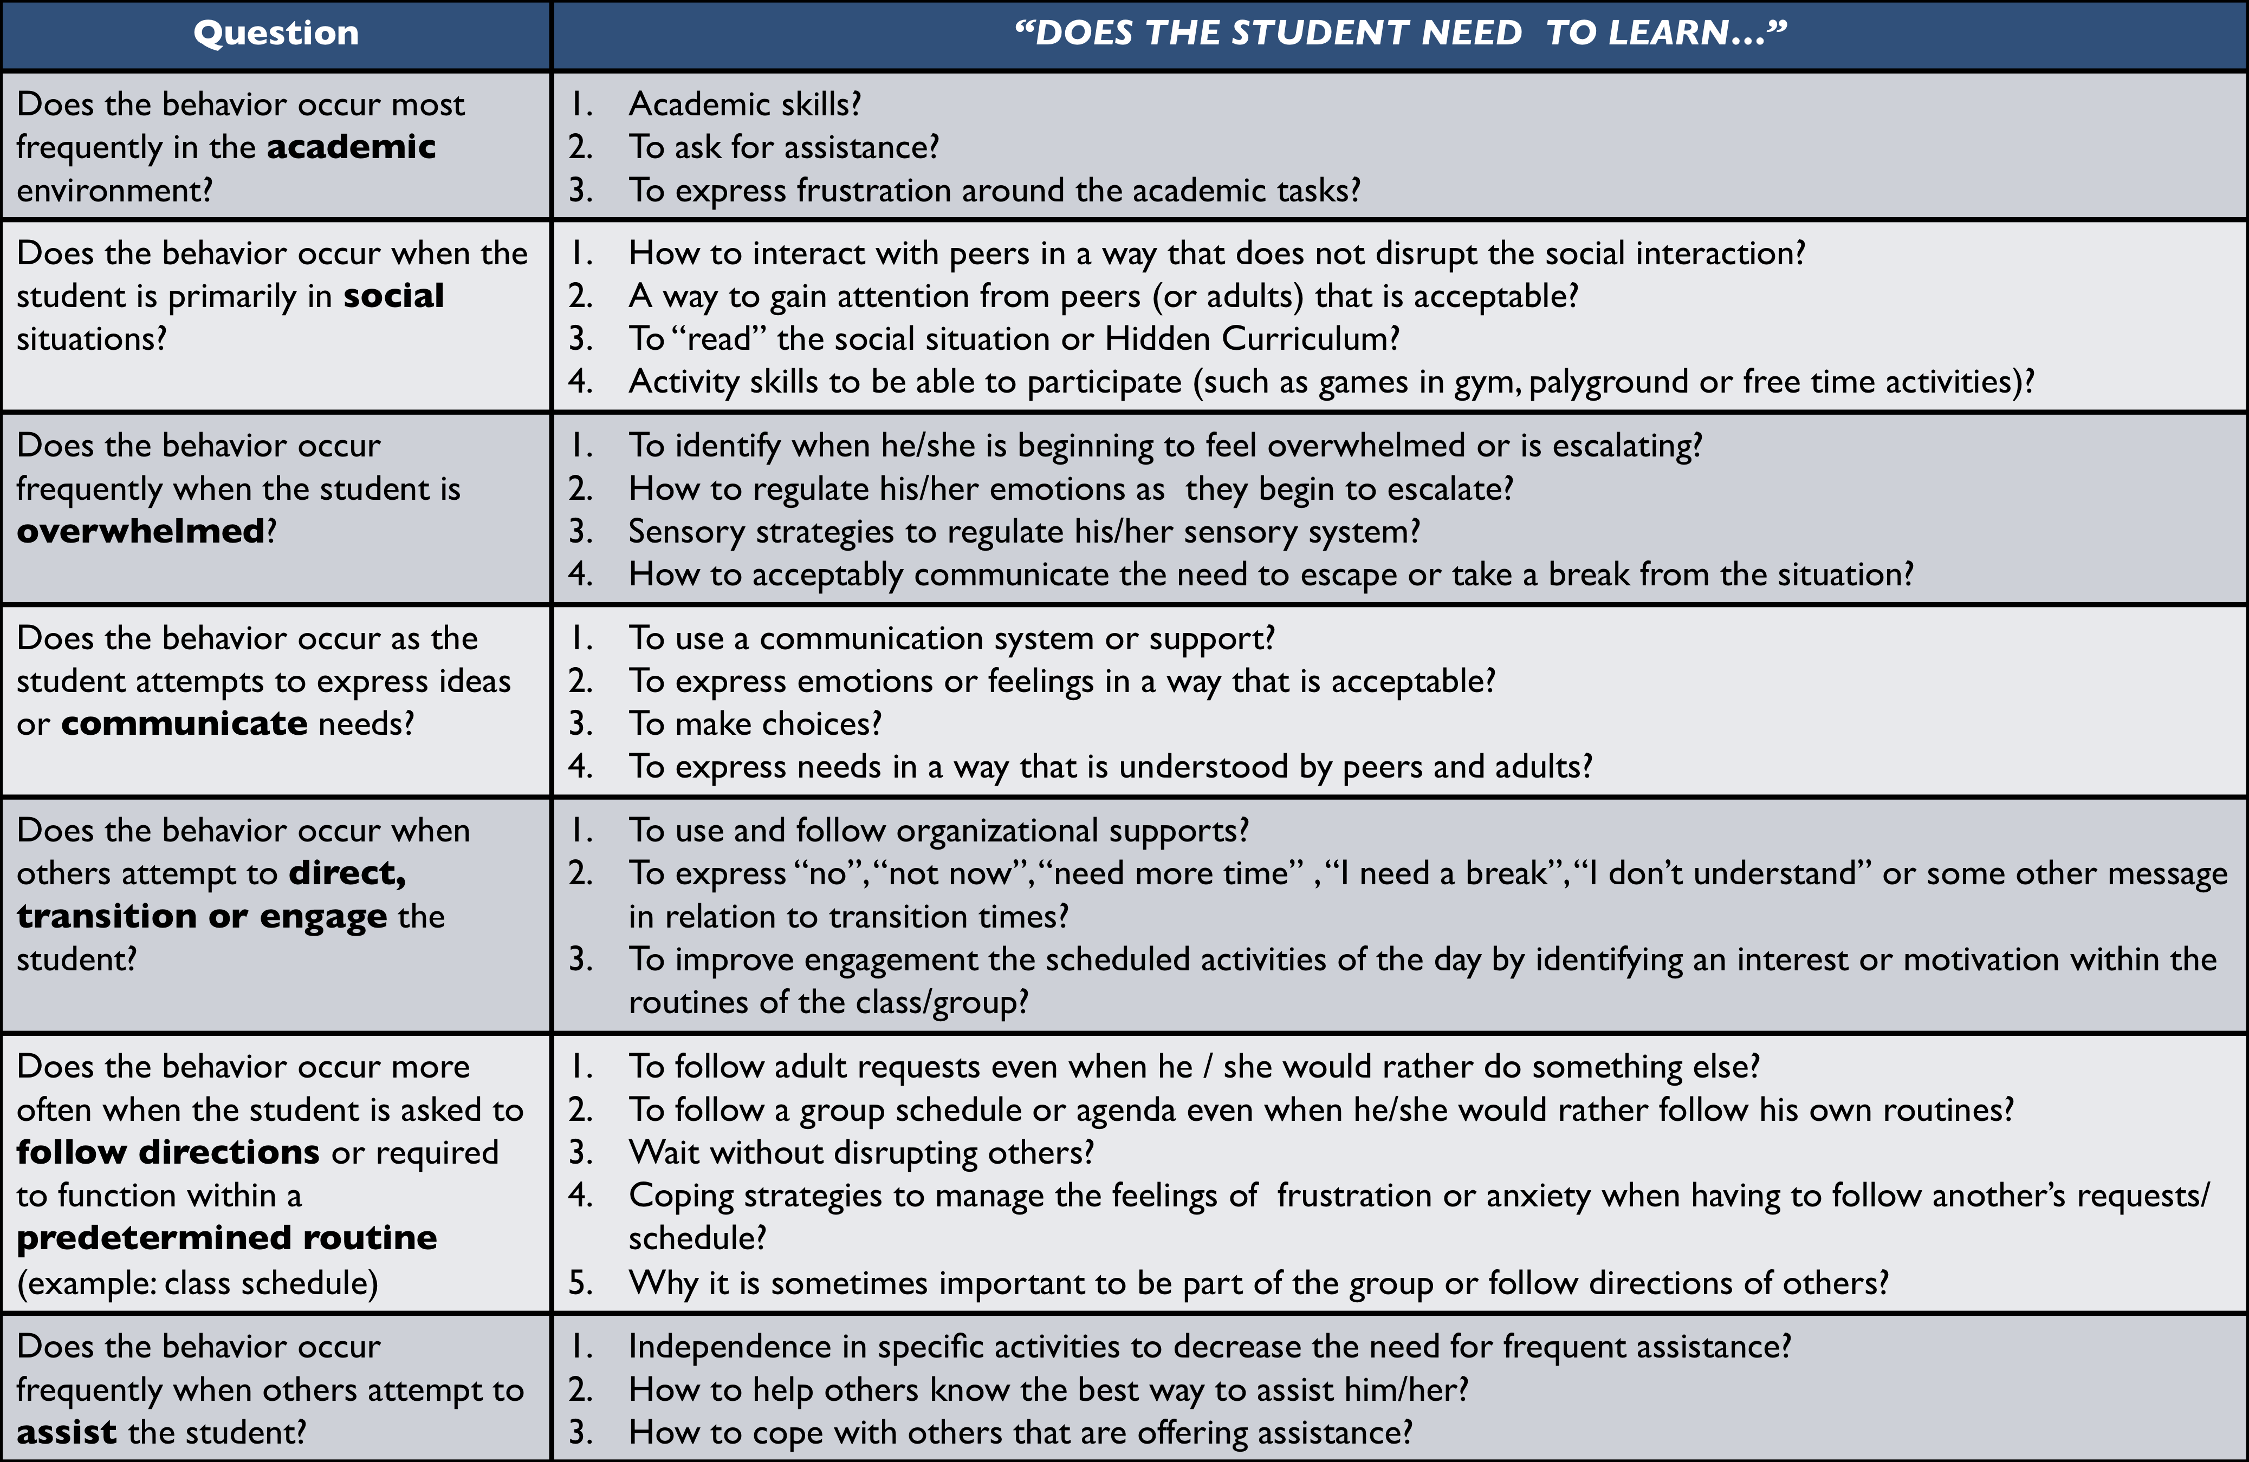
Form 5 Guidance

Related Skills (Forms 1&5)

Long-term Outcome

Resulting Consequences

Consequences (Form 1)

Quick Triggers and Setting Events (Form 1)

Target Behavior (Form 1)

Form 6

New Desired Behavior Path
Current Challenging Behavior Path
STUDENT PSEUDO-NAME:
TEAM:
Replacement Behavior

Function of Behavior (Form 3)

GUIDING QUESTIONS FORMS 7a, 7b, 7c, 7d  REPLACEMENT/RELATED Behavior Plans | What is need specific to the Target Skill?
INTERVENTION.  Will a specific intervention(s) be used to teach the new skill? (EBP) | Social Competency Intervention? Academic Strategy? Communication Intervention?  Emotional or Sensory Regulation Method?
LEARNING STYLE. What strategies or methods will be used to improve learning and skill development that match the students learning style and need | Instructional Style or Environment?  Accommodations?  Tools?
ENVIRONMENTAL MODIFICATIONS. What modifications to the environment will be necessary to achieve an environment that is supportive of learning new skills and may also reduce setting events or triggers? Modifications include modifications in the way others act and react. | Visual Supports to the environment?  Changes to support sensory needs?  Do peers or adults need to learn how to manage their own actions to decrease stressors?

GUIDING QUESTIONS FORMS 7a, 7b, 7c, 7d  REPLACEMENT/RELATED Behavior Plans | What is need specific to the Target Skill?
SENSORY. Will the student require sensory/biological adaptations or interventions to promote learning and using the new skill or to reduce setting events and triggers? | Needed sensory experiences?  Sensory breaks?  Supports for sensory regulation?
SOCIAL AND COMMUNICATION. What social-emotional and communication supports will be needed? How will instruction in these areas be provided to promote learning the replacement skill or to reduce setting events and triggers? Interventions and Supports include modifications in the way others communicate to the student. | Teaching others in the environment how to communicate with the person?  Visual supports for social and/or communication skill building?  Strategies to teach social competence?
REINFORCE. Ways to add Motivation and Reinforcement | Specifically using special interests as part of the educational program?
DATA. How will progress towards the new skill be measured (Data worksheet)? | What measures are meaningful indicators of success?

STUDENT PSEUDO-NAME:
TEAM:
Form 7a
REPLACEMENT SKILLS PLAN: HOW TO TEACH AND REINFORCE (Part a)
Replacement Behavior:

INTERVENTION. What specific intervention(s) will be used to teach the new skill? (EBP)

LEARNING STYLE. What strategies or methods will be used to improve learning and skill development that match the students learning style and needs?

ENVIRONMENTAL MODIFICATIONS. What modifications to the environment will be necessary to achieve an environment that is supportive of learning new skills and may also reduce setting events or triggers? Modifications include the way others act and react.

REPLACEMENT SKILLS PLAN: HOW TO TEACH AND REINFORCE (Part b)
Replacement Behavior:

SENSORY. Will the student require sensory/biological adaptations or interventions to promote learning and using the new skill or to reduce setting events and triggers?

SOCIAL AND COMMUNICATION. What social-emotional and communication supports will be needed? How will instruction in these areas be provided to promote learning the replacement skill or to reduce setting events and triggers? Interventions and Supports include modifications in the way others communicate to the student.

REINFORCE. How will Motivation and Reinforcement be built into the plan?

DATA. How will progress towards the new skill be measured?

STUDENT PSEUDO-NAME:
TEAM:
Form 7b
RELATED SKILLS PLAN: HOW TO TEACH AND REINFORCE (Part c)
Related Skill(s):

INTERVENTION. What specific intervention(s) will be used to teach the new skill? (EBP)

LEARNING STYLE. What strategies or methods will be used to improve learning and skill development that match the students learning style and needs?

ENVIRONMENTAL MODIFICATIONS. What modifications to the environment will be necessary to achieve an environment that is supportive of learning new skills and may also reduce setting events or triggers? Modifications include the way others act and react.

STUDENT PSEUDO-NAME:
TEAM:
Form 7c
STUDENT PSEUDO-NAME:
Form 7d

TEAM:

RELATED SKILLS PLAN: HOW TO TEACH AND REINFORCE (Part d)
Related Skill(s):

SENSORY. Will the student require sensory/biological adaptations or interventions to promote learning and using the new skill or to reduce setting events and triggers?

SOCIAL AND COMMUNICATION. What social-emotional and communication supports will be needed? How will instruction in these areas be provided to promote learning the replacement skill or to reduce setting events and triggers? Interventions and Supports include modifications in the way others communicate to the student.

REINFORCE. How will Motivation and Reinforcement be built into the plan? Consider embedding into instruction and activities.

DATA. How will progress towards the new skill be measured?

Replacement and Related Skills Intervention Plan Checklist
Guidance Form 7e
Specific to the behavior/skills being taught, does the support plan include the following?

- Strategies that eliminate or decrease SETTING EVENTS?

- Interventions that reduce or avoid TRIGGERS?

- Modifications or adaptations to the ENVIRONMENT?

- Student PREFERENCES, STRENGTHS as part of the plan?

- Individualized REINFORCEMENT strategies using student interests?

- Interventions that help avoid REINFORCING CONSEQUENCES of the challenging behavior?

- Plans to TEACH new skills that were identified in STUDENT CHALLENGES?

- Strategies to address SENSORY based challenges or needs?

- Social and communication supports when identified as an area of challenge?

- Strategies to specifically teach the REPLACEMENT behavior?

STUDENT PSEUDO-NAME:
TEAM:
Form 8

List what is reinforcing to your individual. If you aren’t sure, what are you going to do to find out?

Schedule of reinforcement: after what skills/teaching?

Schedule of reinforcement: how often?

Schedule of reinforcement: how much?

Schedule of reinforcement: who is giving?

Schedule of reinforcement: how will you record the data about the reinforcement?

When and how will the team review, update, and revise the reinforcement plan?

Reinforcement Plan to Teach Replacement Behavior and Related Skills

Form 9

Name of Individual:
Element | Does the current strategy include the element? | Strategy:
 |  | Description of Existing Element Features | Revisions of Strategy to Include Missing Element or to Improve Targeted Element
Visual/Tactile | - Yes  - No  - Somewhat
Sensory Consideration | - Yes  - No  - Somewhat
Positive Reinforcement | - Yes  - No  - Somewhat
Individualized & Motivating | - Yes  - No  - Somewhat
Teaches What To Do | - Yes  - No  - Somewhat
Predictable & Consistent | - Yes  - No  - Somewhat
Reliable Implementation | - Yes  - No  - Somewhat

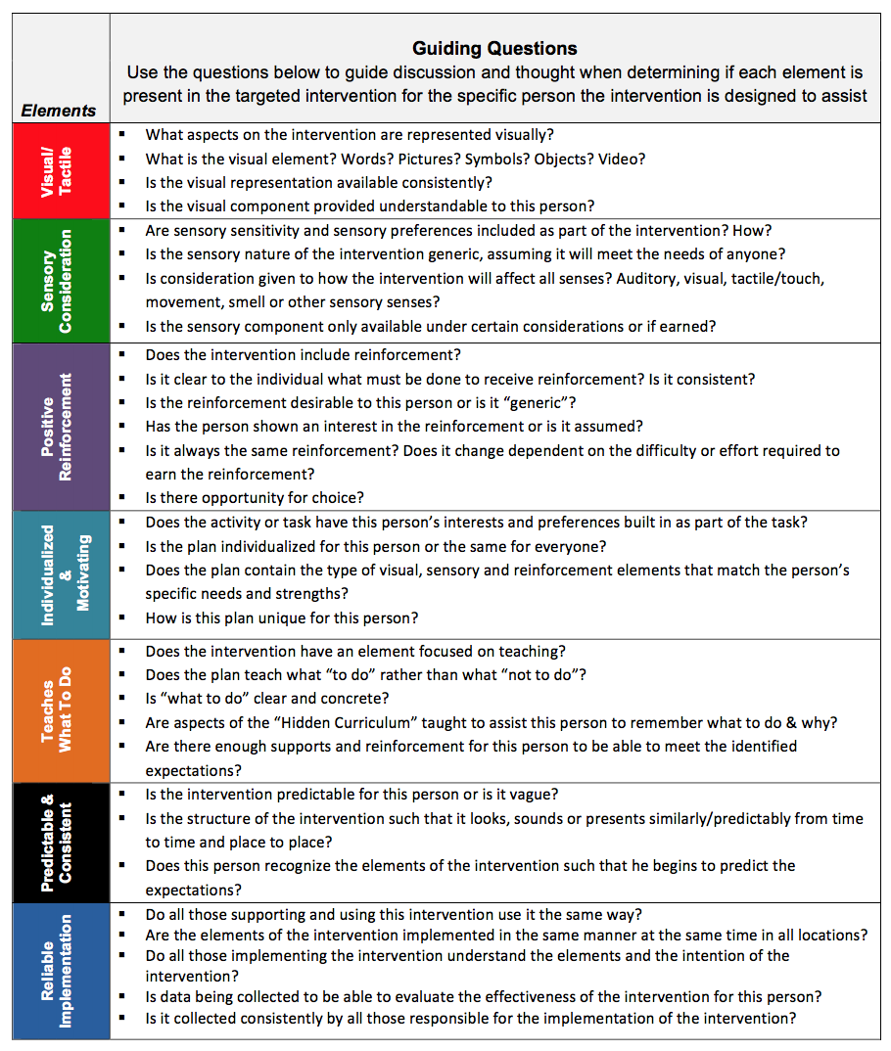

SART Guiding Questions
Guidance Form 9

