- When Complete | Creating an Individualized Behavior Support Plan  Complete Each Step
Select the target individual.
Select the behavior of concern that the team would like to help the individual change
Questions to consider: What behavior is having an impact on the individual’s ability to access learning, LRE, social opportunities, or safety?
What behavior would the team be willing to focus on to learn a new process?
 | Define the behavior in measureable terms | 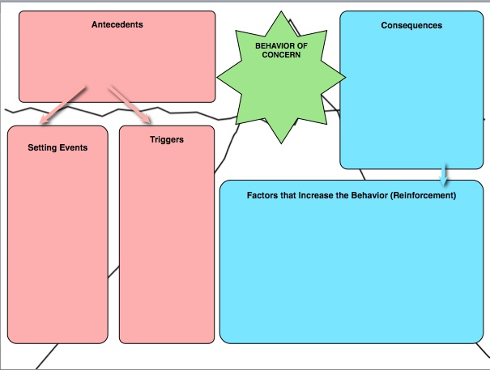
 | Consider data questions for identified behavior. What will you measure? Frequency? Duration? Intensity? How and When? Discuss what you have for baseline data and if you need more (consider safety issues). | 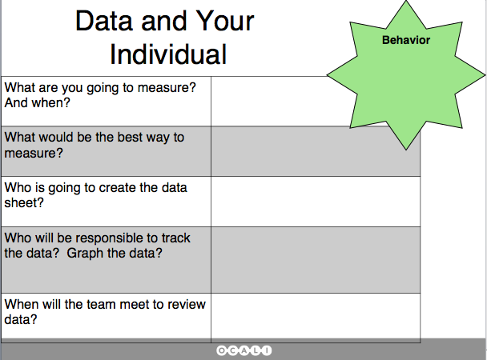
 | Identify and summarize underlying challenges that may be associated with the behavior. Informal assessment questions provided. | 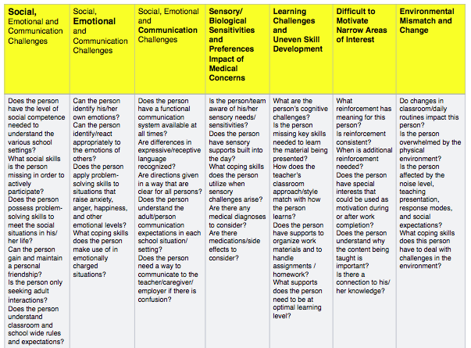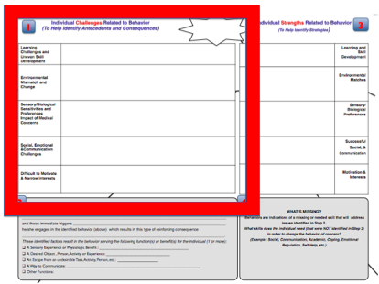
 | Identify antecedents, setting events, triggers, consequences, reinforcement, and hypothesis. These are your initial ideas. You may refine as you go through the process. Guidance questions for potential antecedents and consequences are provided. | 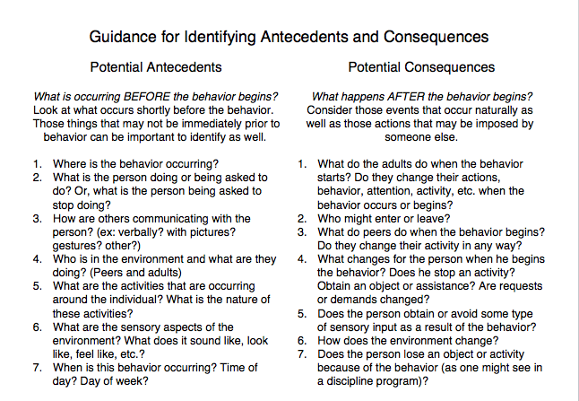
 | Revise Step 1 with any new information you discovered.
 | Complete the “Why Worksheet” using the information from the expanded FBA form. | 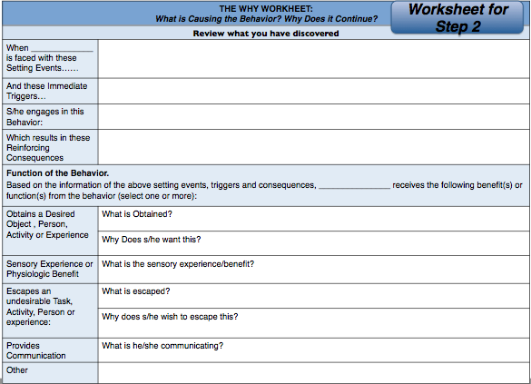
 | Summarize and transfer the information from your individual’s “Why Worksheet” into section 2 of the form. | 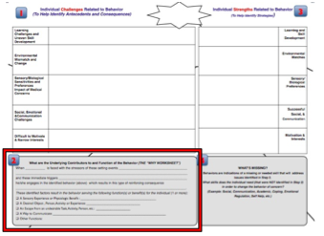
 | List strengths and skills of the individual that can be used to help support a behavior change. | 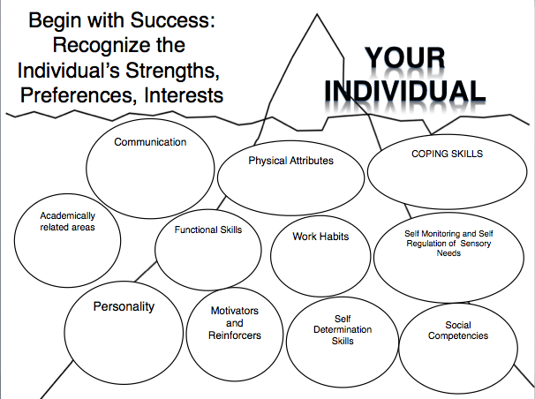
 | Summarize strengths and skills in section 3 of intervention form | 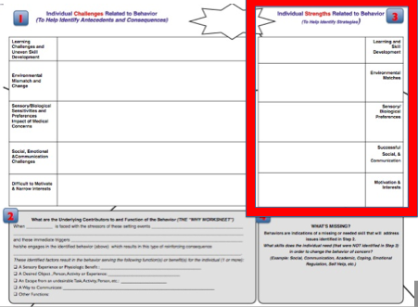
 | Identify additional skills needed to improve the behavior of concern. Review the individual’s current strengths and skills, looking for gaps in skill and knowledge that would be helpful and necessary. Guiding questions to help identify needed skills are provided. | 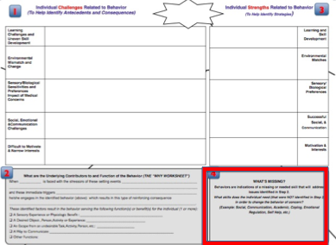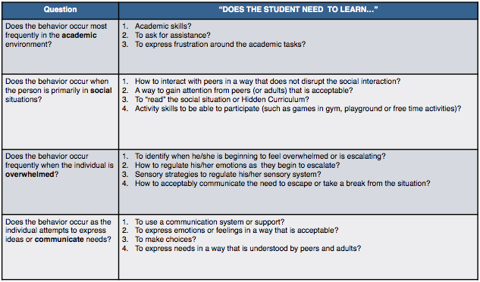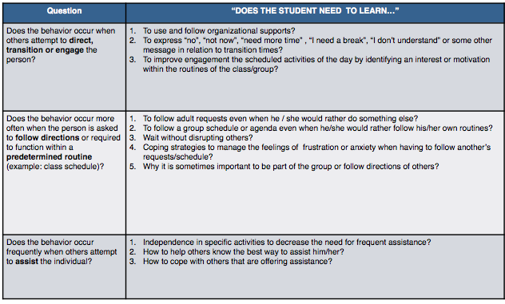
 | Identify Substitute/Replacement Skills and Related skills needed to change the target behavior and support learning. | 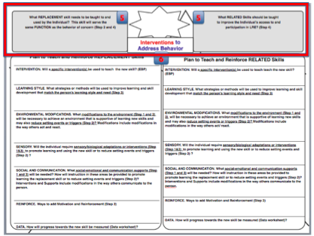
 | Consider reinforcement questions for identified behavior. You will individualize and improve success of the plan with the discovery of this information. | 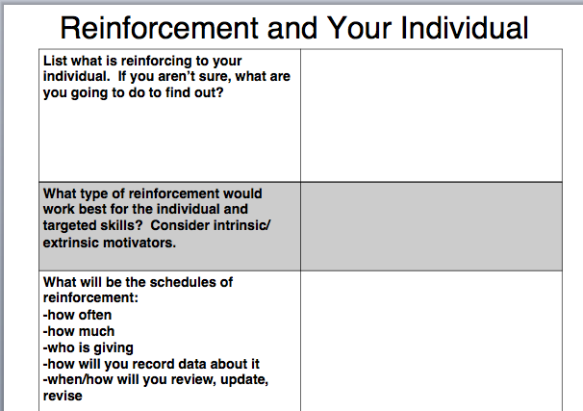
 | Identify possible interventions/strategies for identified replacement and related skills. Align or connect the areas of challenge (Section 1), strengths (Section 3) with the selected strategies. Guiding questions to help choose interventions are provided. After choosing strategies/interventions, a strategy checklist is provided to be sure the team has covered all areas. | 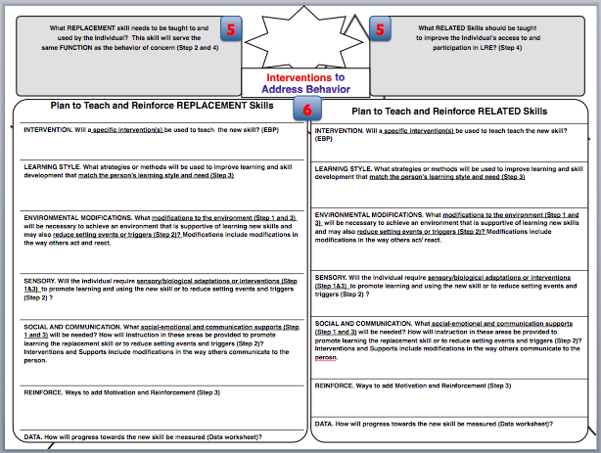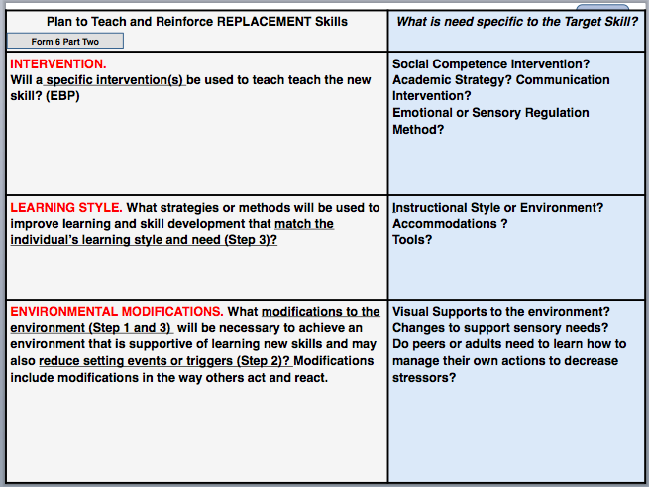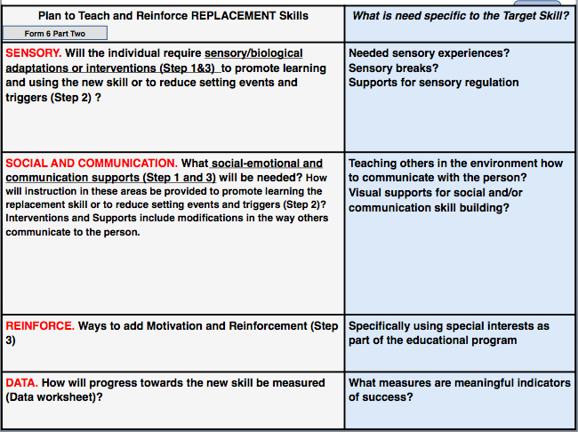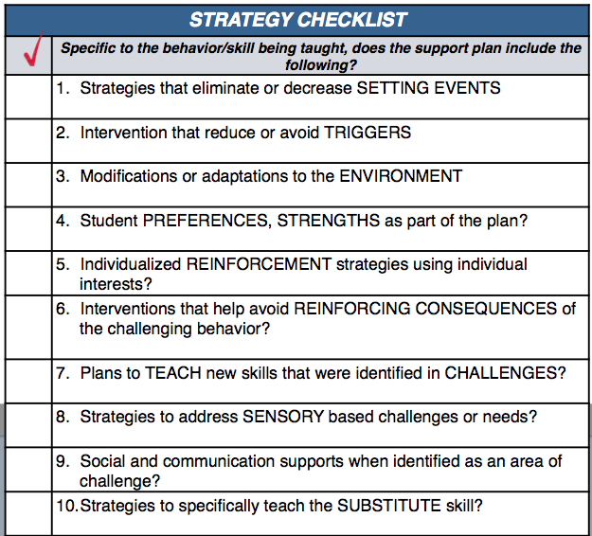
 | Choose the interventions/strategies/supports for the INITIAL implementation of the plan. Strategies to: teach the new skills to replace behaviors, reinforce new skills, change triggers and setting events, use strengths and individual motivators.
 | Use Strategy Assessment and Revision Worksheet and Guiding Questions sheet to review strategies that will be part of the behavior plan | 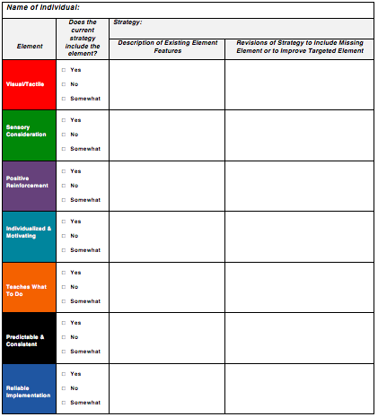  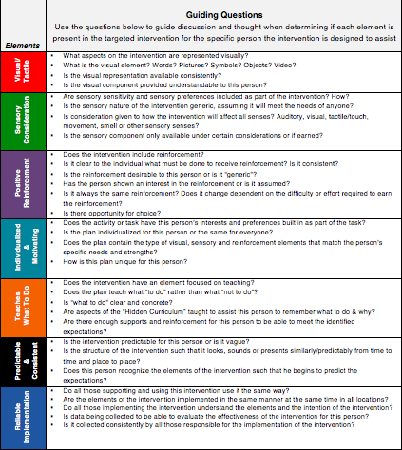
 | If in a school district or agency, transfer information to approved or preferred behavior plan form
 | Optional Forms:  Fill in Action Steps for Behavior Support Plan Sheet to help organize next steps. | 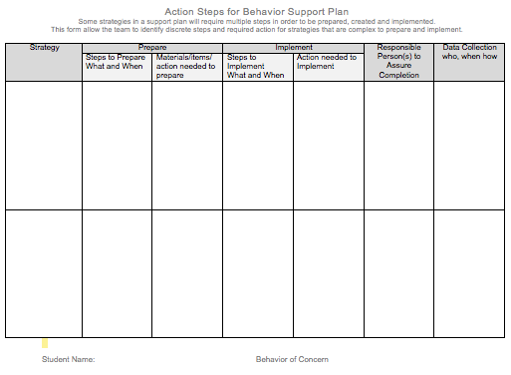
 | Fill in Review and Check Plan Sheet to see if plan addresses all areas. | 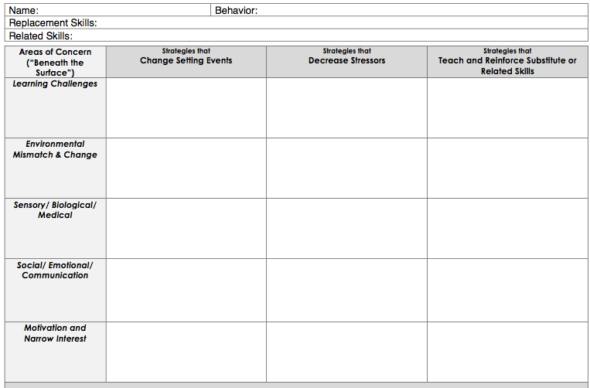
 | Fill in Actions and Reactions of Others Form as part of antecedent/consequence discussion. | 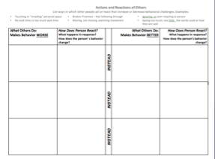
 | If you want more space for Substitute/Replacement and Related Skills Identification and to list your Plan to Reinforce and Teach those skills, fill in the full-page form of each. | 